Accounts Payable

Country Finance Bahrain

Departmental Operating Instruction (DOI)
Accounts Payable

Process Description 3
Product 3
Reference Number 3
Background 3
Objective 3
Impacted Units 3
Ownership 3
Remarks 3
Effective From 3
Risk of Non-Compliance 3
Executive Summary for Approvers 3
Detailed Process 3
Control Check Points for ensuring compliance: 10
Details of reports, if any pertaining to the process: 10
Exception Handling and Escalation: 10
Record Retention: 10
Quality Assurance Checks: 10
Performed By: 10
Prepared by: 11
Reviewed by: 11
Approved by: 11
Revision History 11
Distribution List: 12

Process Description | In country accounts payable process
Product | Vendor’s invoices payments, Cross Border Recharges (CBR) and manual payments

Reference Number
Background | To document the payment process’s
Objective | To ensure that expenditures goes through the bank’s proper channels for processing (e-Proc, T&E & SODA) in line with the Group Business Expenditure Standard, and to improve control over spends and provide a better audit trail.
Impacted Units | Domestic Business Unit (DBU)
Ownership | Country Finance – Accounts Payable Team

Remarks
Effective From | May 2014 (Reviewed Annually or if there are changes to the group expenditure and travel policy and procedures)
Risk of Non-Compliance | Fraud and bribery risk, duplicate payments, compliance with the Group Delegated Authorities
Executive Summary for Approvers | This document details the payment process. This also contains key controls to observe in ensuring the accuracy and quality of the process.

Detailed Process

S. No. | Activity | Timelines | Responsibility
1 | Introductions  The purpose of this DOI is to provide guidance on how to process third parties’ payments (vendor’s payments and CBR’s).  Payments should be in line with the requirements of the Group Business Expenditure Standard. |  | Country Finance
2 | Groups Mandated Systems  As per Group Business Expenditure Standard, Group standard systems are mandatory where available.  The Group’s mandatory processes and systems (where available) include: eProcurement, International Mobility (“IM”) / HR and SODA.  Any payments that do not follow the standard invoice payment process are considered manual payments. Manual payments are not allowed unless exceptional circumstances prevent payment through the standard process. A rigorous approval process is in place and must be completed before any such payments are made. Please refer to section 5 in this document.  Invoices that do not go through the Purchase Order (PO) route are processed as a manual invoice. Any such payments should be on exceptional basis only and require approval from the country CFO or his delegates, as well as country supply chain manger. However, the payment should be processed centrally through Accounts Payable Unites Team (APU) in GBS (Bangalore/Chennai). Please refer to section 4 in this document. |  | Country Finance / payment requester
3 | PO invoices  Invoices for DBU (U140), are raised in eProcurement and submitted directly to AP team for processing. The invoice should be scanned by the vendor to AP team for processing and it should have the PO number.  Once the invoice interfaced in the system it will come to country finance queue in the Tax-Q system. Finance needs to provide the following:  - Provide the Purpose of payment (POP). Refer Annexure 2.  - Classify the invoices into one of the following VAT categories:  - Full Tax Invoice: those are the compliant VAT invoices issued by a taxable person in line with National Bureau of Revenue (NBR) guideline. Below are the basic requirements need to be checked:  - The label “Tax Invoice”  - Name, address (as registered with NBR), and Tax Registration Number (TRN) of the supplier.  - Name and address (as registered with NBR) of the customer, i.e. SCB Bahrain.  - Date and sequential tax invoice number.  - Description, quantity, value, unit price and date of supply.  - Value of discounts (if any), and the net value.  - The VAT rate and amount of VAT due.  - Total amount due, inclusive of VAT.  - Exchange rate applied (in case of foreign currency invoices).  - Where a transaction is exempt from VAT, it should be clearly stated.  - Where the profit margin scheme is used, a reference that VAT has been charged based on the profit margin mechanism.  Below is a tax invoice example as per NBR requirements.  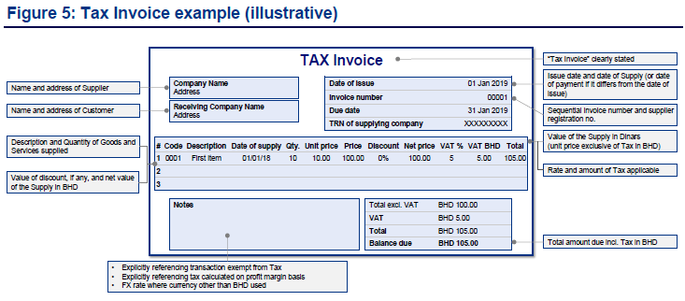  - Simplified Tax Invoice: those are the invoices which are issued by a taxable person and don’t have the following:  - The label “Tax Invoice”  - Name and address (as registered with NBR) of the customer, i.e. SCB Bahrain.  - Sequential tax invoice number  - Quantity, value, unit price and date of supply.  - Value of discounts (if any), and the net value.  - Exchange rate applied (in case of foreign currency invoices).  - Where a transaction is exempt from VAT, it should be clearly stated.  Note: simplified tax invoice is only acceptable where the consideration of the supply does not exceed BHD 500 (inclusive of VAT).  - Unregistered Vendor Purchases: those are the invoices issued any vendor/government authorities which are not registered with NBR as taxable person.  - Zero Rated Purchases: those are the invoices issued by a taxable person, where the supply is taxable at the rate of 0%, this include the following:  - Domestic and International transportation  - Basic food items  - Healthcare services, Medicines and medical equipment  - Educational services  - Construction services for new buildings  - Domestic oil and gas  Note: the invoice should meet the tax invoice requirements mentioned above, although the supply is zero rated.  - Exempt Purchases: those are the invoices issued by a taxable person where the supply is VAT exempt supplies. This include the following:  - Real estate supplies  - Financial services  - Tax Credit Note: those are the credit notes issued by a taxable person with vat amount.  - Reverse Charge Invoice: those are the invoices issued by an oversees supplies where the supplies is taxable by nature. The VAT amount should be calculated and written on the invoice by country finance.  VAT amount should be calculated in FCY (in case of foreign currency invoices) and in LCY using the central bank exchange rate as of the invoice date.  - GCC Tax Invoice: The supplier should be based out of GCC states. (Currently not in use).  - Inter Business Unit Transfers: this is for interbranch transactions (CBRs).  - Out of Scope: this will be mainly for the following:  - Invoices where the supply is provided before 1st Jan 2019.  - Multi purposes voucher (MPV). As per section 4.6 of NBR guideline, the issue of an MPV and each subsequent transfer of that MPV for consideration is not a supply falling within the scope of VAT.  - Other: currently only Electricity and Water Authority (EWA) bills are marked as Other, as EWA is registered as a taxable person but VAT is not being charged yet. |  | Country Finance / payment requester
4 | Manual invoices (non e-proc invoices)  Invoices that do not go through the PO route are processed as a manual invoice.  In order to process any manual invoice, the requester needs to:  - Provide an Invoice  - Prepare the non e-proc memo which needs to be approved by the cost centre owner, country supply chain manager and the CFO or his delegate  Please refer Annexure 1 for the memo.  - Scan the non e-proc memo along with the invoice to BH, APUeInvoice for processing.  Control checks:  - Ensure that all manual invoices are approved by the cost centre owner, country supply chain manager and the CFO or his delegates.  - Ensure that the payment is made to the vendor as appearing in the invoice. Unless a clear instruction received from the vendor states something else.  - Ensure that the invoice amount is within the approver DOA limit as per GDAM. The only exception to this is GSAM legal and professional fees, which are not covered by GDAM.  This exception was confirmed by the “Group Corporate Secretariat”. |  | Country Finance / payment requester
5 | In country payments:  In country payments are considered as Manual payments and would be either One-off manual payments or Recurring manual payments.  Manual payments  Manual Payments are defined as those items not paid via the standard invoice payment process and where implemented, not paid via PeopleSoft Accounts Payable (PSAP).  In order to process any manual payment, the requester needs to:  - Provide an Invoice  - Provide the non e-proc memo which needs to be approved by the cost centre owner, country supply chain manager and the CFO or his delegate.  - Since this is an in-country payment, you need to prepare an OTT form for telex transfer (Annexure 3) and take the approved documents to Operations to print a cheque.  Manual payments are classified to either One-off Manual Payments or Recurring Manual payments.  One-off manual payments  The following documents/approvals are required for the one-off payments.  - Evidence in the form of a statement of the nature of the expense to support that the request is a one-off payment, and not a recurring obligation  - Supplier number of the Vendor in PSAP vendor if applicable, else Screening confirmation to be attached, noting that the screening results are valid for 48 hours.  - Obtain approval from a Managing Director (MD) of the requesting Business function (or CEO if no there is on MD in country)  - Obtain CFO approval  - Approval document must indicate the account that needs to be debited  Recurring manual payments  All recurring manual payments regardless of value or method of payment are considered manual payments.  Such recurring manual payments are only permitted where a written dispensation approved by the policy owner is held by the department that originates such payments.  Except for MD (or CEO) approval, all the requirements mentioned above under one-off manual payments need to be met. Additionally, a dispensation must be in place for the recurring manual payments.  After any manual payment, you need to:  - Record the manual payment in eOPS  https://eopsvip05.hk.standardchartered.com:9443/eopssec/index.jsp  Note: on a quarterly basis the CFO log need to be retrieved from eOPS and approved by the CFO. This approval needs to uploaded in eOPS for the quarterly manual payments CST check.  - Mark the invoice as PAID and send it to the APU team in GBS (Bangalore/Chennai) for recording purposes in PeopleSoft Accounts Payable and posting the entry in the GL.  AP standard memo needs to be used. Refer Annexure 4  Please note that all manual payments will be paid through the payment suspense account.  Below are the ebbs payment suspense accounts:  BU CCY Ebbs Account No  DBU BHD 09-0906743-50  DBU USD 09-0906743-50  Since AP team will be posting the GL entry, the below entry needs to be posted in ebbs by country to clear the Payment Suspense Account.  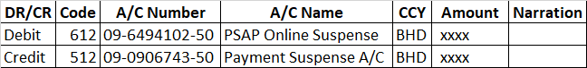  Control checks:  - Ensure that all manual payments are approved by the cost centre owner and the CFO or his delegates.  - Ensure that dispensation is in place for all recurring payments.  - Ensure that the vendor is on-boarded. Or screening is performed if not on-boarded.  - Ensure that the payment is executed within 48 hours of the screening result.  - Ensure that the payment is made to the vendor as appearing in the invoice. Unless a clear instruction received from the vendor states something else.  - Ensure that the invoice amount is within the approver limit as per GDAM. The only exception to this is GSAM legal and professional fees, and Tax/VAT payments which are not covered by GDAM.  This exception was confirmed by the “Group Corporate Secretariat”. |  | Country Finance / payment requester
6 | Cross Border Recharges (CBR)  The CBR payments are managed centrally in GBS) Bangalore / Chennai) by APU CBR team. |  | Country Finance
7 | Clearing payment suspense account  As mentioned above, payment suspense account should be mainly used for all in-country vendor payments. Please note that there might be other transactions hit the payment suspense account also, for example CBR funds received, income from The Benefit Company, UK VAT refund … etc.  Please follow the following process to clear the balance in the GL:  - Take an extract of the PSGL account number 140-288843-800 for the period required. And reconcile it to the trial balance account (YTD balance of 288843)  - Extract a transaction archival from the eBBS for the payment suspense account (BHD/USD 09-0906743-50) for the period required.  - Then check and compare if the same amounts are showing in both the extracts  - If the amounts are the same in both extracts, then a PSGL entry need to be posted to move the balances from payment suspense to the respective cost centres and GL account.  All items in the payment suspense accounts should be cleared in the same month and any aged items should be escalated as per the below escalation grid:  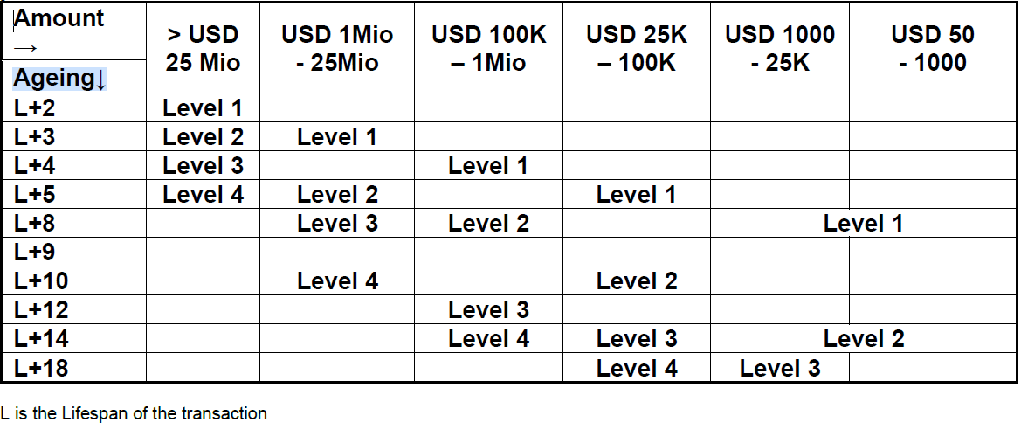  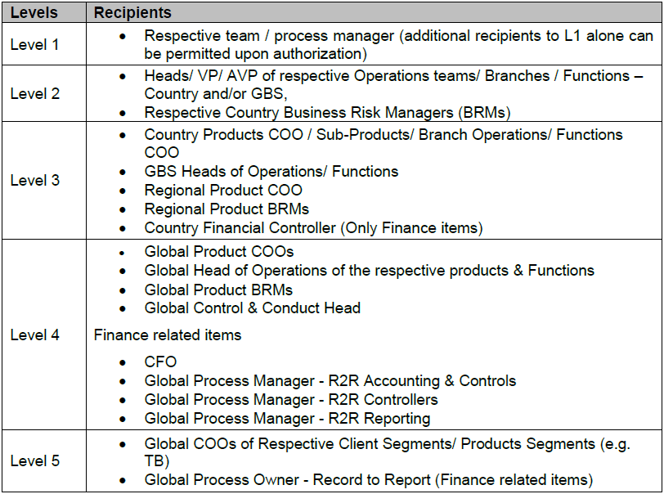  Aging of the items are calculated as follows:  Aging = Current Date – Vale Date – Life Span  Control checks:  - GL extract is reconciled to the ebbs extract  - The payments were properly approved  - Ensure that you have the correct PSGL chart fields to clear the balances |  | Country Finance
9 | - Preparer: Finance Manager  - Covered for preparer: Finance Manager  - Approver : CFO  - Covered for approver: Finance Senior Manager |  | N/A

Annexure 1 -
Annexure 2 -
Annexure 3 -
Annexure 4 -
Annexure 5 -

Delegation of Authority, if any applicable to the process: | NA
Control Check Points for ensuring compliance: | Control Checks:  - Approval from country supply chain manager (if required) to process the non e-Procurement payments.  - Approval from the cost centre owner / line manager. As per the latest group delegation of authority DOA  - CFO’s approval or delegate to process the non e-Procurement payments

Details of reports, if any pertaining to the process:
Exception Handling and Escalation: | Escalation to the CFO must be undertaken if there is any payment request which is not in line with the Group Business Expenditure Standards and when there is a doubt of fraud or bribery.
Record Retention: | Proper documentation of the invoices, the out of e-Proc memo and email approvals have to be kept on file for audit and future use purposes.
Quality Assurance Checks: | All kind of payments should be processed in line with the group expenditure and travel policy and procedures. | Performed By: | CFO or his delegate.

Prepared by:
NAME | DESIGNATION | SIGNATURE | DATE
Ali Abdulkarim | Finance Manager |  | Nov 2025

Reviewed by:
NAME | DESIGNATION | SIGNATURE | DATE
Sai Venkata Ramana Redla | Finance Senior Manager |  | Nov 2025

Approved by:
NAME | DESIGNATION | SIGNATURE | DATE
Sai Venkata Ramana Redla | Finance Senior Manager |  | Nov 2025

Revision History

Version | Date | Reason | Initiator | Approver | Comments
11 | Nov 2025 | Annual review | Ali Abdulkarim | Sai Venkata Ramana Redla
11 | Nov 2024 | Annual review | Ali Abdulkarim | Sai Venkata Ramana Redla
10 | June 2023 | Annual review | Ali Abdulkarim | Sai Venkata Ramana Redla
9 | Oct 2021 | Update the DOI with the POP requirements and the new OTT form | Ali Abdulkarim | Sai Venkata Ramana Redla
8 | June 2021 | Annual review | Ali Abdulkarim | Sai Venkata Ramana Redla
7 | June 2020 | Annual review | Ali Abdulkarim | Sai Venkata Ramana Redla
6 | June 2019 | Annual review and alignment with the updates on the Group Business Expenditure Standards | Ali Abdulkarim | Sai Venkata Ramana Redla
5 | June 2018 | Annual review and alignment with the updates on the group expenditure policy and procedures | Ali Abdulkarim | Sai Venkata Ramana Redla
4 | June 2017 | Annual review and alignment with the updates on the group expenditure policy and procedures | Ali Abdulkarim | Sai Venkata Ramana Redla
3 | June 2016 | Annual review and alignment with the new group expenditure policy and procedures | Ali Abdulkarim | Sai Venkata Ramana Redla
2 | May 2015 | Annual review | Ali Abdulkarim | Sai Venkata Ramana Redla
1 | May 2014 | First Draft | Ali Abdulkarim | Sai Venkata Ramana Redla

Distribution List:
S. No. | Designation
1 | N/A
2
3
4

